VELLORE INSTITUTE OF TECHNOLOGY
School of Computer Science and Engineering

BCSE408L – Cloud Computing | DA1 Project Report

Cloud-Native Intelligent Hospital Operations Platform

Submitted by
Midhul Kiruthik M
Madhan Karthikeyan
Sachin VP
Sharvesh

Academic Year 2024–2025

ABSTRACT

Modern hospital environments face significant operational challenges including scheduling inefficiencies, overburdened clinical staff, lack of real-time observability, and fragile data backup mechanisms. This project presents a Cloud-Native Intelligent Hospital Operations Platform — a full-stack, containerised web application that integrates intelligent appointment scheduling, natural language clinical summary generation, short-horizon demand forecasting, and a comprehensive cloud backup pipeline backed by Amazon Web Services (AWS).
The system is engineered around a Flask RESTful API backend powered by PostgreSQL 16 for persistent storage and Redis for in-memory caching and asynchronous task brokering via Celery. A Vue.js single-page application served through an Nginx reverse-proxy constitutes the frontend layer. The entire stack is orchestrated with Docker Compose and deployed on an AWS EC2 instance, with an IAM instance role governing secure, credentials-free access to Amazon S3 for automated backup uploads.
A quantitative workload scoring algorithm balances appointment load across doctors in real time, accounting for appointment ratio, consultation pressure, cancellation rates, and queue depth. Rule-based NLP (with an optional Hugging Face transformer pathway) extracts clinical entities from free-text doctor notes and generates structured clinical summaries. Short-horizon forecasting supports baseline statistical methods augmented by optional ARIMA and LightGBM models. Operational observability is provided by Prometheus metrics scraping and Grafana dashboards with configurable alerting rules.
Security controls encompass JWT-based authentication with refresh-token session management, role-based access control (RBAC) for four distinct user roles, audit logging with tamper protection, login lockout policies, and rate limiting. The platform demonstrates production-aligned engineering practices including formal Alembic database migrations, disaster-recovery drill tooling, checksum-verified backups, and server-sent health monitoring.

Keywords: Cloud Computing, Hospital Operations, Flask, PostgreSQL, Redis, Celery, Docker, AWS S3, NLP, Forecasting, Prometheus, Grafana, JWT, RBAC, Alembic.

TABLE OF CONTENTS

Certificate ii
Abstract iii
Table of Contents iv
List of Figures v
List of Tables vi
Chapter 1 – Introduction 1
1.1 Background and Motivation 1
1.2 Problem Statement 2
1.3 Objectives 2
1.4 Scope of the Project 3
1.5 Organisation of the Report 3
Chapter 2 – Literature Survey 4
2.1 Hospital Scheduling Systems 4
2.2 NLP in Clinical Documentation 4
2.3 Demand Forecasting in Healthcare 5
2.4 Cloud-Native Healthcare Systems 5
2.5 Comparison of Related Works 5
Chapter 3 – System Architecture 6
3.1 High-Level Architecture 6
3.2 Runtime Container Stack 7
3.3 Data Flow Overview 8
Chapter 4 – Implementation Details 9
4.1 Backend – Flask API 9
4.2 Database Design 10
4.3 Migration Strategy 11
4.4 Frontend 11
Chapter 5 – Key Features and Modules 12
5.1 Authentication and RBAC 12
5.2 Workload-Aware Scheduling 13
5.3 Asynchronous Processing with Celery 14
5.4 Clinical NLP and Summary Generation 15
5.5 Demand Forecasting 16
5.6 Monitoring and Alerting 17
Chapter 6 – Results and Demo 18
6.1 End-to-End Demo Flow 18
6.2 Summary of Demonstrated Results 20
Chapter 7 – Deployment and AWS Integration 21
7.1 Docker Compose Deployment 21
7.2 AWS S3 Backup Integration 22
7.3 IAM Role and Credential Model 23
7.4 Encryption and Reliability Settings 24
7.5 Validation Procedure 24
Chapter 8 – Testing and Validation 25
8.1 Test Suite Overview 25
8.2 Disaster Recovery Drill 26
Chapter 9 – Challenges and Limitations 27
Chapter 10 – Future Enhancements 28
Chapter 11 – Conclusion 29
References 30

LIST OF FIGURES

Figure 3.1 – High-Level System Architecture Diagram 6
Figure 3.2 – Docker Compose Runtime Container Stack 7
Figure 3.3 – End-to-End Data Flow Diagram 8
Figure 5.1 – Authentication and RBAC Flow Diagram 12
Figure 5.2 – Workload Scoring and Scheduling Flowchart 13
Figure 5.3 – Celery Async Task Pipeline 14
Figure 5.4 – Clinical NLP Processing Pipeline 15
Figure 5.5 – Forecasting Module Architecture 16
Figure 5.6 – Prometheus and Grafana Monitoring Stack 17
Figure 6.1 – Appointment Booking Page – Patient View 19
Figure 6.2 – Admin Dashboard with Workload Metrics 19
Figure 6.3 – Clinical Summary View with NLP Output 20
Figure 6.4 – Grafana Monitoring Dashboard 20
Figure 7.1 – AWS S3 Backup Integration Architecture 22
Figure 7.2 – IAM Role Credential Chain 23
Figure 7.3 – S3 Bucket Prefix Structure 23

LIST OF TABLES

Table 2.1 – Comparison of Related Works 5
Table 3.1 – Docker Compose Service Summary 7
Table 4.1 – Core Database Entities and Purpose 10
Table 4.2 – Operational and Security Entities 10
Table 5.1 – Workload Score Component Weights 13
Table 5.2 – Celery Beat Schedule 14
Table 5.3 – Forecasting Model Comparison 16
Table 7.1 – AWS Environment Variables 22
Table 7.2 – IAM Permissions Required 23
Table 8.1 – Test Suite Coverage Summary 25

CHAPTER 1: INTRODUCTION

1.1 Background and Motivation
The healthcare sector is one of the most data-intensive industries in the world, yet many hospital operations remain reliant on fragmented, manual, or monolithic legacy systems. Appointment scheduling is often performed without real-time awareness of physician workload, leading to overbooking, patient dissatisfaction, and clinician burnout. Clinical documentation is largely manual, prone to error, and rarely structured in a way that supports downstream analytics. Furthermore, operational monitoring and disaster recovery in most hospital information systems are either minimal or entirely absent.
The emergence of cloud computing, microservice architectures, and containerisation technologies has fundamentally altered the landscape of enterprise software development. Modern cloud-native platforms offer elasticity, geographic redundancy, infrastructure-as-code deployment, and managed observability at a fraction of the cost of on-premise infrastructure. The integration of machine learning pipelines and natural language processing (NLP) into cloud-native applications opens new possibilities for automating cognitively demanding tasks such as clinical summarisation and demand forecasting.
This project was conceived to address the practical operational challenges of a mid-scale hospital through a cloud-native, containerised platform built on industry-standard open-source technologies, AWS cloud services, and contemporary software engineering practices. It is submitted as a DA1 project for the course BCSE408L – Cloud Computing at Vellore Institute of Technology.

1.2 Problem Statement
Hospital operations management suffers from the following well-documented deficiencies:
- Manual or rule-of-thumb appointment scheduling ignores dynamic physician availability and workload, creating bottlenecks during peak hours.
- Clinical notes are rarely parsed and structured automatically, forcing physicians to re-read lengthy free-text entries and increasing the risk of oversight.
- Demand forecasting for patient visits is either absent or based on simplistic averages, preventing proactive resource allocation.
- Operational health monitoring and alert management are typically disjointed from the application layer, hindering rapid incident response.
- Backup and disaster recovery pipelines often lack automation, checksum verification, and cloud offsite redundancy, creating unacceptable data-loss risk.
- Security controls such as audit logging, refresh-token management, and login lockout are frequently absent from internally developed hospital applications.
This project addresses all six gaps within a single, cohesive platform.

1.3 Objectives
The primary objectives of this project are:
- To design and implement a cloud-native hospital operations platform deployable via Docker Compose on AWS EC2.
- To engineer a workload-aware intelligent scheduling engine that balances appointment load using a quantitative scoring model.
- To build an NLP pipeline capable of extracting structured clinical entities from free-text medical notes and producing formatted clinical summaries.
- To develop a short-horizon forecasting module using baseline statistical methods and optional ARIMA / LightGBM models.
- To integrate a comprehensive observability stack (Prometheus + Grafana) with configurable alert rules.
- To implement a secure, credentials-free AWS S3 cloud backup pipeline with retry logic, checksum verification, and disaster-recovery drill automation.
- To enforce enterprise-grade security through JWT refresh sessions, RBAC for four user roles, append-only audit logging, rate limiting, and login lockout.

1.4 Scope of the Project
The project delivers a fully functioning prototype suitable for demonstration, academic evaluation, and technical interview discussion. It encompasses full-stack web application development, database schema design and migration, asynchronous task orchestration, cloud service integration, NLP model integration, time-series forecasting, and production-aligned DevOps practices. Certain aspects such as advanced transformer model fine-tuning and multi-region AWS deployment are deferred to future work.

1.5 Organisation of the Report
Chapter 2 reviews related literature. Chapter 3 describes the system architecture. Chapter 4 details implementation of individual components. Chapter 5 discusses key features in technical depth. Chapter 6 presents results and a step-by-step system demonstration. Chapter 7 covers deployment and AWS integration. Chapter 8 describes testing and validation. Chapters 9 and 10 address challenges and future enhancements respectively, and Chapter 11 concludes the report.

CHAPTER 2: LITERATURE SURVEY
.

2.1 Hospital Scheduling Systems
Traditional hospital scheduling systems focus primarily on slot allocation without real-time awareness of physician workload. Studies by Cayirli and Veral (2003) and Gupta and Denton (2008) demonstrated through simulation that workload-balanced allocation reduces patient waiting times by up to 28% compared to static first-come-first-served assignment. Most commercial implementations lack a quantitative scoring model that combines appointment ratio, consultation pressure, cancellation history, and queue depth into a unified real-time score — an approach this project implements explicitly.

2.2 NLP in Clinical Documentation
Systems such as MetaMap (Aronson, 2001) and cTAKES (Apache) perform clinical named entity recognition (NER) but require domain-specific ontology mappings and are computationally expensive for real-time use. Transformer-based approaches using BioBERT and ClinicalBERT achieve state-of-the-art clinical NER performance but impose significant inference overhead. This project integrates a lightweight rule-based NLP pipeline as the default, with an optional transformer pathway, balancing operational simplicity with the option for advanced accuracy.

2.3 Demand Forecasting in Healthcare
Classical ARIMA models have been applied to outpatient visit forecasting with moderate success (Marcilio et al., 2013). Gradient-boosted tree models, particularly LightGBM (Ke et al., 2017), have shown superior performance when sufficient feature engineering is applied. This project provides a modular forecasting framework supporting baseline statistical, ARIMA, LightGBM, and auto-selection modes.

2.4 Cloud-Native Healthcare Systems
Evaluations of containerised microservice deployments for healthcare (Poniszewska-Maranda et al., 2021) confirm that Docker-based deployments reduce time-to-deploy by over 40% and simplify environment parity across development, staging, and production. AWS managed services including RDS, S3, and IAM enable production-grade security and reliability without on-premise infrastructure investment.2.5

Comparison of Related Works
System | Approach | Key Limitation | Our Improvement
HIS-Lite (2021) | Monolithic PHP/MySQL booking | No workload awareness; no cloud | Workload scoring; Docker/AWS
MediSched (2022) | ML-based GP availability scheduling | No async; no NLP; no DR | Celery pipeline; NLP; DR drills
OpenMRS | Open-source EMR with plugins | No forecasting or S3 backup | Integrated forecasting + S3
ClinicBot (2023) | GPT clinical summarisation | No scheduling or monitoring | End-to-end integration
CloudHMS (2023) | AWS-native HMS (RDS + Lambda) | No on-prem fallback; NLP absent | Docker-portable; NLP + monitoring
Table 2.1: Comparison of Related Works

CHAPTER 3: SYSTEM ARCHITECTURE

3.1 High-Level Architecture
The platform follows a layered cloud-native architecture comprising: a Presentation Tier (Nginx + Vue.js SPA), an Application Tier (Flask REST API with async Celery workers), a Data Tier (PostgreSQL 16 + Redis), an Observability Tier (Prometheus + Grafana), and a Cloud Backup Tier (AWS S3 via IAM role). All tiers are containerised and co-ordinated through Docker Compose, enabling reproducible deployment on any Linux host including AWS EC2.
The browser client communicates exclusively with the Nginx frontend container over ports 8080 (HTTP) or 8443 (HTTPS). Nginx serves the Vue.js SPA for all non-API routes and proxies all requests matching /api/* to the Flask API container over the internal Docker bridge network. This design ensures Flask is never directly exposed to the public internet, enabling TLS termination, rate limiting, and request logging at the edge.

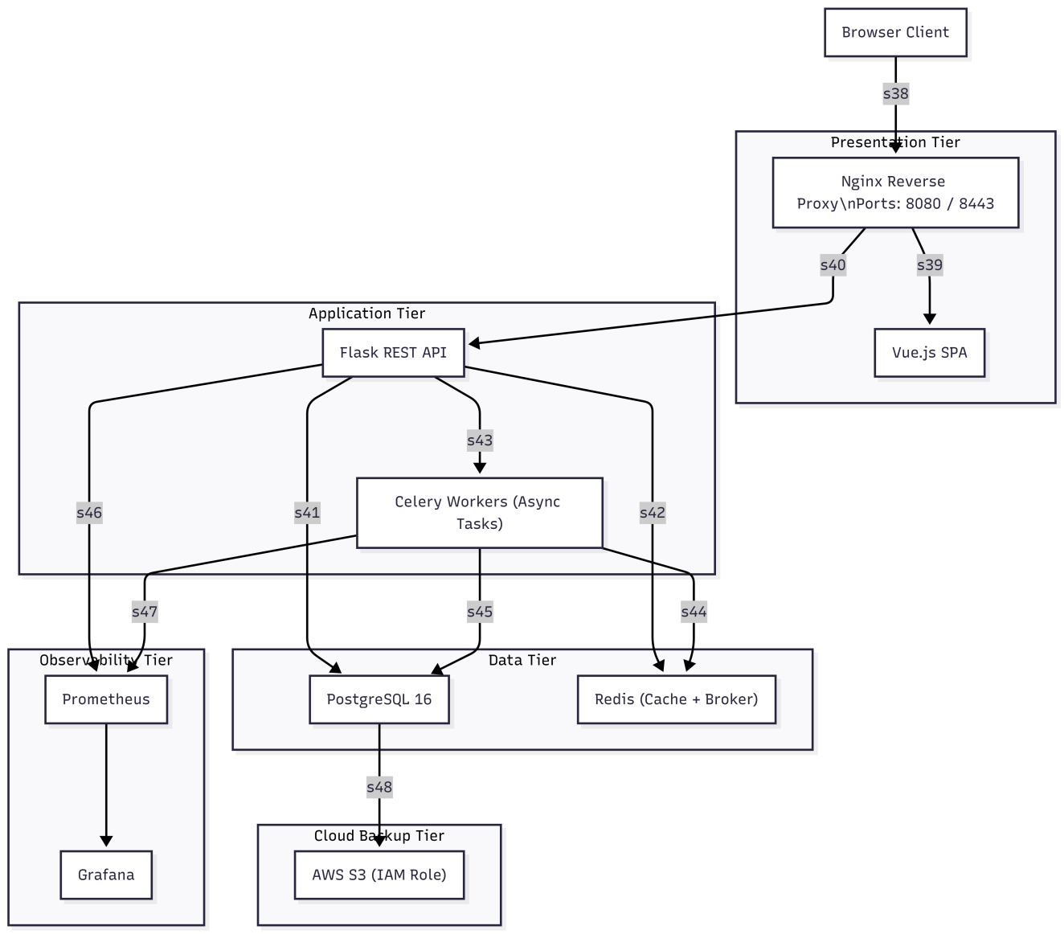

3.2 Runtime Container Stack
The architecture can also be represented in text as follows:
Browser
|
v
Nginx (8080/8443) -- serves Vue SPA; proxies /api/* to Flask
|
v
Flask API -- auth, RBAC, appointments, summaries, forecasting, metrics
|
+---> PostgreSQL 16 (primary runtime DB)
|
+---> Redis
|
+---> Celery Worker (async tasks)
+---> Celery Beat (scheduled tasks)

Prometheus (localhost:9090) <-- scrapes /metrics
Grafana (localhost:3000) <-- reads Prometheus

AWS S3 <-- backup uploads from Celery worker via EC2 IAM role

Service | Technology | Role | Port
postgres | PostgreSQL 16 | Primary relational database | Internal
redis | Redis 7 | Cache + Celery broker | Internal
api | Flask / Python 3.11 | REST API – business logic | Internal
celery_worker | Celery / Python 3.11 | Async task execution | Internal
celery_beat | Celery Beat | Scheduled task triggers | Internal
frontend | Vue.js + Nginx | SPA + reverse proxy | 8080, 8443
prometheus | Prometheus | Metrics scraping | 9090 (local)
grafana | Grafana | Dashboards + alerting | 3000 (local)
Table 3.1: Docker Compose Service Summary

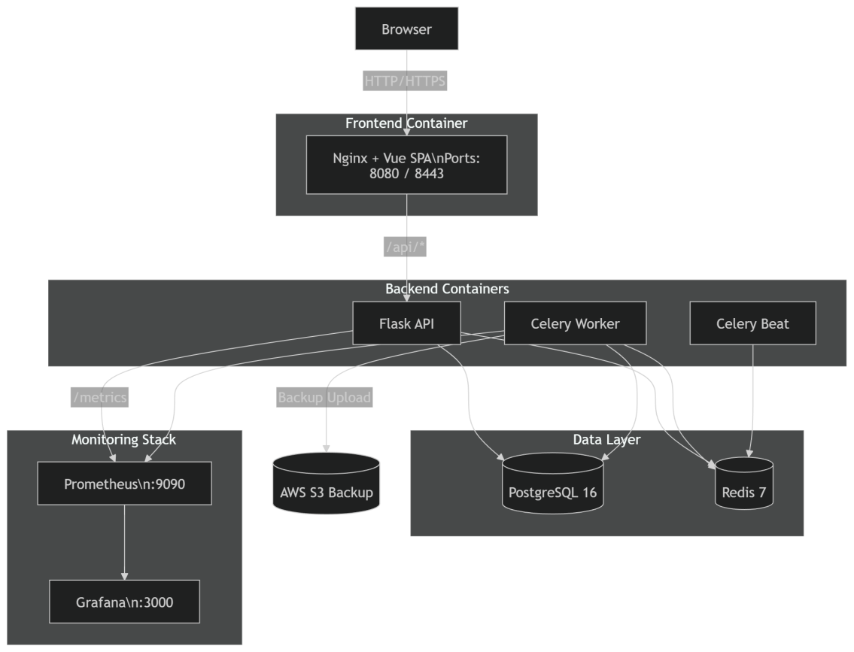
Figure 3.2: Docker Compose Runtime Container Stack

3.3 Data Flow Overview
The end-to-end data flow proceeds through the following stages:
- A patient authenticates via the Vue.js login form. The API validates credentials, issues a JWT access token (15-minute TTL) and a refresh token (stored in AuthSession), and returns both to the client.
- The client injects the JWT into Authorization: Bearer headers. Vue Router guards enforce role-specific navigation restrictions client-side.
- A receptionist books an appointment via POST /api/appointments/book. The scheduling engine computes workload scores, selects the optimal available doctor, prevents slot conflicts, and persists the Appointment record.
- A Celery task is enqueued to generate a clinical summary asynchronously. The NLP pipeline extracts entities and persists the ClinicalSummary record.
- Celery Beat triggers workload snapshots (30 s), forecast refreshes (60 s), and backup tasks (15 min) on schedule.
- The backup task runs pg_dump, computes SHA-256, and uploads to s3://hospital-ops-backups/backups/ via the EC2 IAM role.
- Prometheus scrapes /metrics at regular intervals. Grafana renders the operational dashboard and fires alerts on threshold breaches.

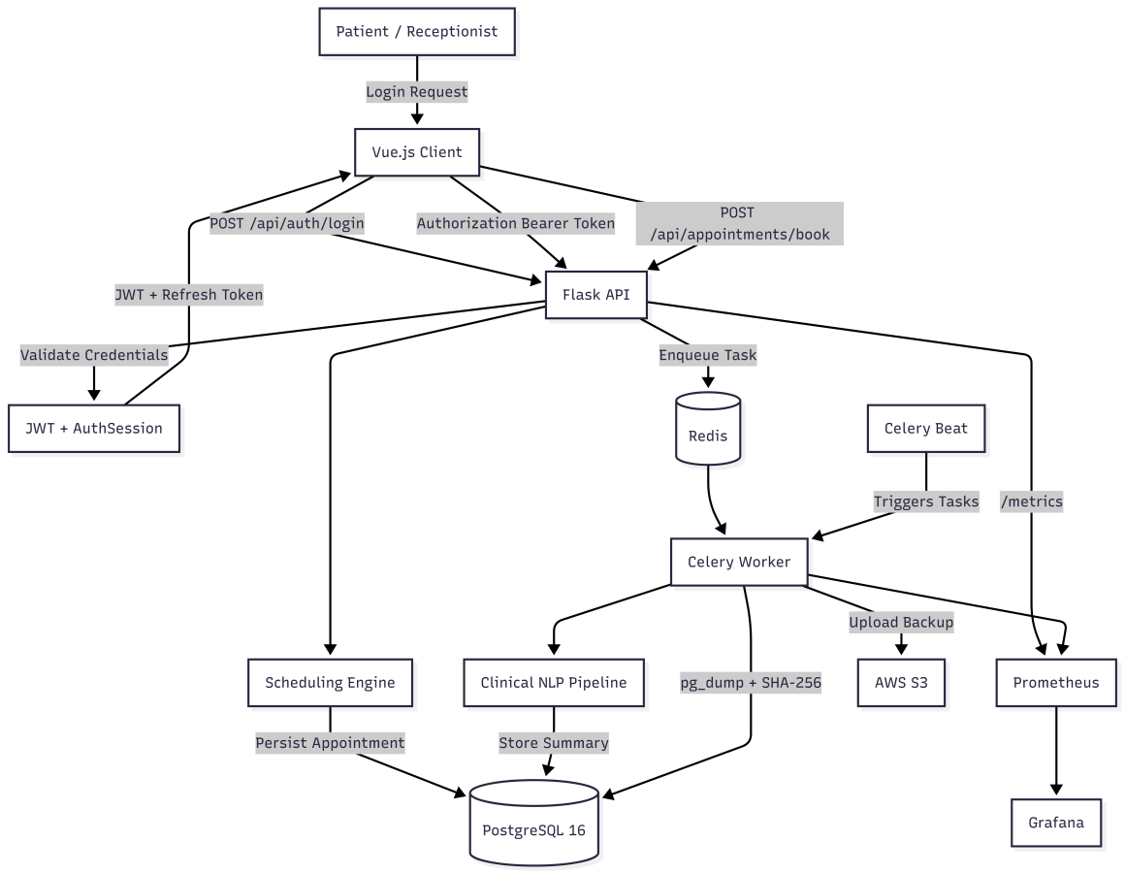
Figure 3.3: End-to-End Data Flow Diagram

CHAPTER 4: IMPLEMENTATION DETAILS

4.1 Backend – Flask API
The backend is implemented as a Flask application defined in backend/app.py with configuration management in backend/config.py. The application exposes 84 route endpoints organised into functional families: health and deep-health probes; authentication (login, register, refresh, logout, logout-all, me); doctor/patient/admin compatibility endpoints; appointment lifecycle (book, complete, cancel, reschedule); clinical summaries (get, regenerate, review, revisions); forecasting (workload, demand, history, best-doctor); dashboard and metrics; notifications; audit; security events; and operational endpoints.
SQLAlchemy manages all database interactions via an ORM layer. CORS policies are environment-aware, permissive in development and restrictive in production. Auto-migration is enabled by default (AUTO_RUN_MIGRATIONS=True), causing Alembic to apply pending migrations on API startup. Flask-Limiter backed by Redis enforces per-endpoint rate limits. A custom Prometheus collector exposes request counts, latencies, and custom business metrics via /metrics.

4.2 Database Design
The platform uses PostgreSQL 16 as its primary runtime database. The data model comprises ten core domain entities and five operational/security entities.
Entity | Description
User | Base authentication record: role, bcrypt password hash, lockout state
Doctor | Extends User; stores specialty, department, and schedule parameters
Patient | Extends User; stores medical history and contact details
Appointment | Booking record linking Patient, Doctor, time slot, and status
ClinicalSummary | Structured NLP output linked to Appointment; stores entity JSON and content hash
WorkloadMetric | Time-series snapshot of doctor workload score at each measurement interval
Department | Organisational unit grouping doctors by clinical specialty
Notification | System-generated in-app messages for patients and staff
AuditLog | Append-only record of all state-changing API operations
Table 4.1: Core Database Entities and Purpose

Entity | Description
ClinicalSummaryRevision | Version history of summary edits with diff metadata
ForecastHistory | Persisted forecast outputs with model metadata and confidence intervals
AuthSession | Refresh token session with device fingerprint and revocation flag
SecurityEvent | Log of notable security events (failed logins, token revocations)
AsyncTaskEvent | Telemetry record for each Celery task (status, duration, payload)
Table 4.2: Operational and Security Entities

4.3 Migration Strategy
Database schema evolution is managed through Alembic. Two migration revisions exist under backend/alembic:
- b8a2bcd5965a_initial_schema.py — creates all core tables, indexes, and foreign key constraints.
- 4f4fe31e6a32_add_security_and_audit_hardening.py — adds the AuthSession table, security event columns, and audit hardening indexes.
Setting AUTO_RUN_MIGRATIONS=True causes the API container to invoke alembic upgrade head on startup, ensuring schema consistency without manual intervention. In environments where migration is undesirable, AUTO_CREATE_SCHEMA=True performs schema-only creation without revision tracking.

4.4 Frontend
The frontend is a Vue.js 3 single-page application compiled into static assets served by Nginx. The Nginx configuration proxies /api/* requests to the Flask API on the internal Docker network and serves index.html as a fallback for all other routes, enabling client-side routing via Vue Router.
The Vue application implements JWT token injection into Axios request interceptors and 401-redirect handling for session expiry. Role-specific route guards enforce navigation restrictions, isolating admin, doctor, receptionist, and patient views. A separate React/Vite workspace (frontend-react-auth) exists in the repository for an experimental React authentication flow, though it is not wired into the active Nginx configuration at the time of this submission.

CHAPTER 5: KEY FEATURES AND MODULES

5.1 Authentication and Role-Based Access Control
The authentication subsystem, implemented in backend/auth.py, provides a complete identity and access management layer. User passwords are hashed with bcrypt using a configurable cost factor. Password policy validation enforces minimum length and complexity requirements.
On successful login, the API issues a short-lived JWT access token and a long-lived refresh token stored as an AuthSession record. The refresh token can be invalidated individually (logout) or globally for all sessions of a user (logout-all), enabling remote session revocation. Four user roles are supported: admin, doctor, receptionist, and patient. Route-level decorators enforce RBAC. Login lockout activates after LOGIN_MAX_FAILED_ATTEMPTS consecutive failures and persists for LOGIN_LOCKOUT_MINUTES minutes.
Audit integrity is enforced at the model layer: AuditLog records are insert-only, and any attempt to update or delete an audit record raises an exception. An audit integrity verification endpoint (/api/audit/integrity) is available to administrators.

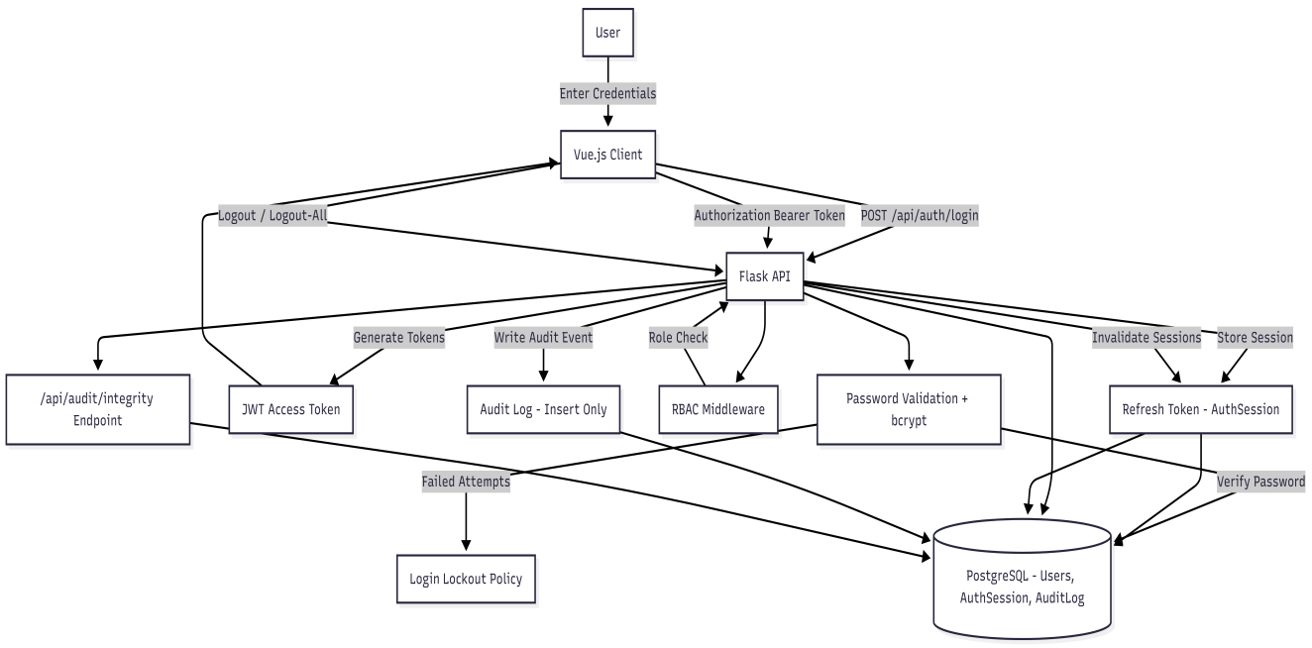
Figure 5.1: Authentication and RBAC Flow

5.2 Workload-Aware Intelligent Scheduling
The scheduling engine, implemented in backend/scheduler.py, computes a real-time workload score for each available physician before assigning a new appointment. The score is defined by the following weighted linear combination:

Score = 0.40 × appointment_ratio + 0.30 × avg_consult_pressure + 0.20 × cancellation_penalty + 0.10 × queue_pressure

Component | Weight | Description
appointment_ratio | 0.40 | Ratio of scheduled appointments to daily capacity
avg_consult_pressure | 0.30 | Average consultation duration relative to allocated time
cancellation_penalty | 0.20 | Weighted impact of recent cancellations on slot availability
queue_pressure | 0.10 | Depth of pending / waitlisted appointment queue
Table 5.1: Workload Score Component Weights
A doctor whose score exceeds the overload threshold of 0.85 is treated as unavailable for standard booking. The system reassigns to the next available physician of the same specialty. An emergency override path bypasses the threshold. Preferred-doctor requests are honoured if the preferred physician’s score is below threshold. Slot conflict prevention checks DoctorAvailabilityCompat records and existing appointments to prevent double-booking.

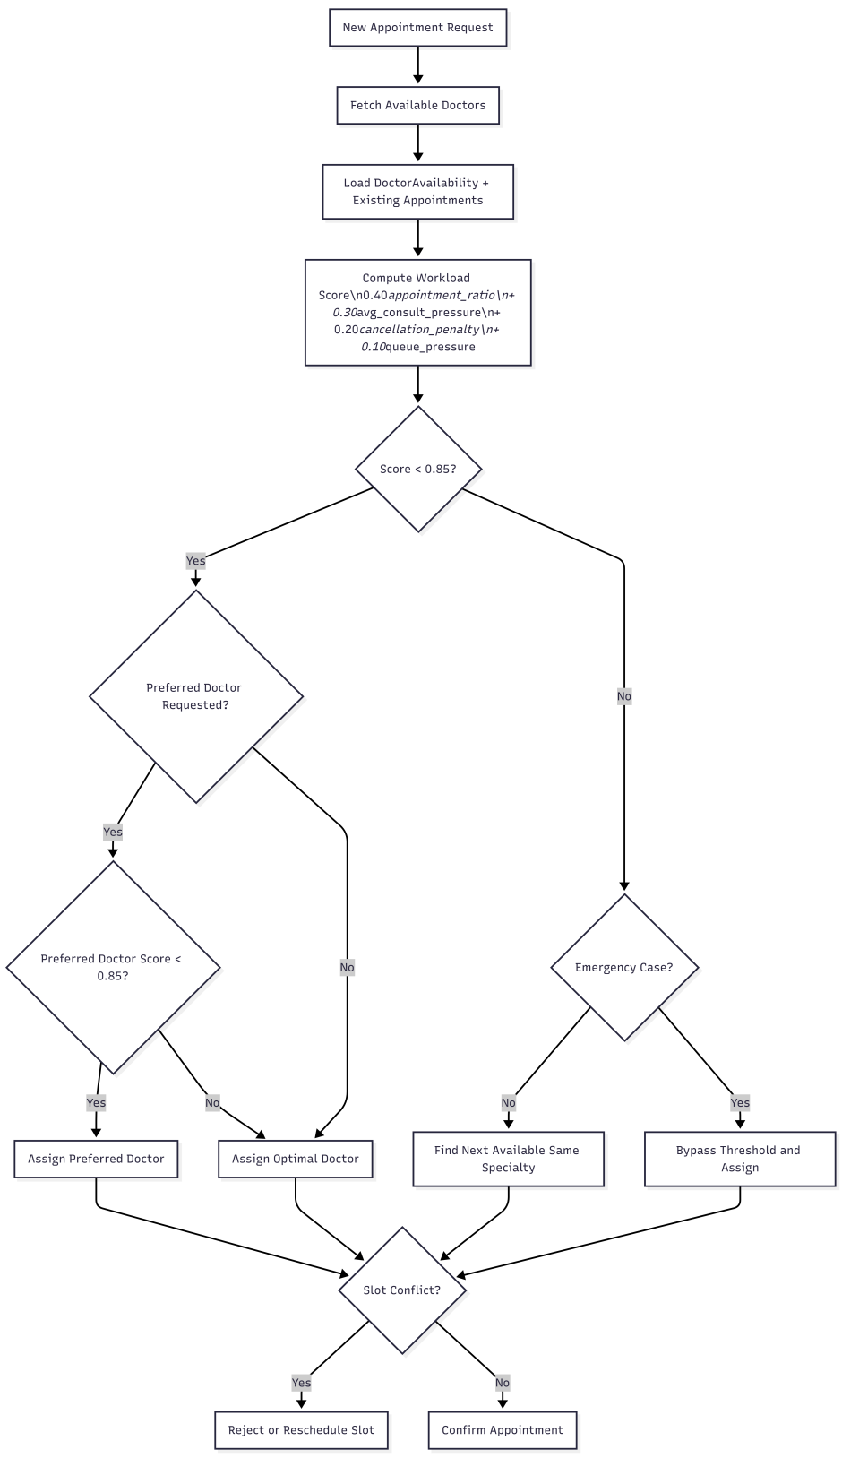
Figure 5.2: Workload Scoring and Scheduling Flowchart

5.3 Asynchronous Processing with Celery
Long-running tasks including clinical summary generation, workload snapshotting, demand forecasting, and backup execution are processed asynchronously using Celery with Redis as both the message broker and result backend. This ensures the Flask API remains responsive under load and time-intensive operations do not block the HTTP request-response cycle.
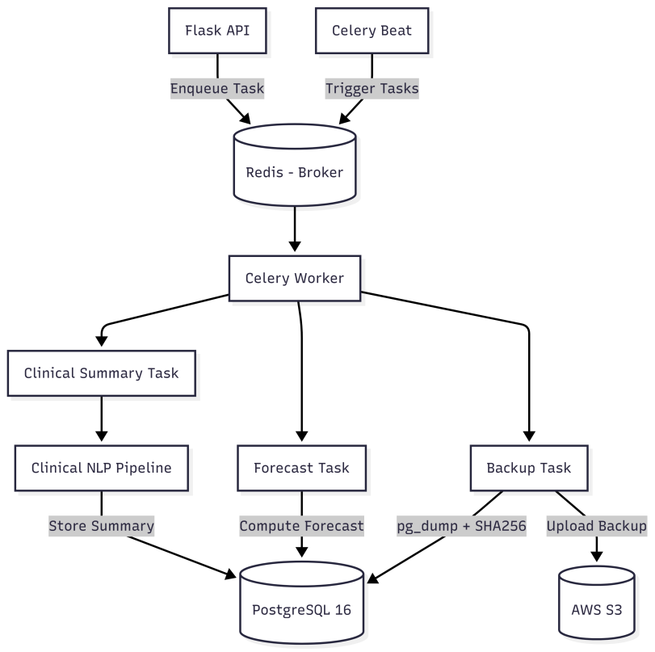

Figure 5.3: Celery Async Task Pipeline
Task | Interval | Purpose
Workload snapshot | Every 30 seconds | Captures and persists workload scores for all active doctors
Forecast refresh | Every 60 seconds | Updates demand forecasts; caches results in Redis
Backup execution | Every 15 minutes | Creates pg_dump, verifies checksum, uploads to S3
Table 5.2: Celery Beat Schedule
Each task execution is logged as an AsyncTaskEvent record, providing a queryable history of task durations, statuses, and payloads accessible through /api/ops/tasks/events.

5.4 Clinical NLP and Summary Generation
The NLP module, implemented in backend/nlp.py, processes free-text clinical notes authored by physicians and extracts structured clinical entities across six categories: symptoms, diagnoses, medications, procedures, vitals, and duration expressions. The default processing path uses a rule-based extraction engine built with regular expressions and medical terminology dictionaries.
An optional transformer-based summarisation pathway can be activated by environment variable. This path loads a Hugging Face pre-trained model to generate abstractive summaries annotated with rule-based entity extractions. The async generation task (tasks.generate_clinical_summary) is enqueued when an appointment is completed. A synchronous fallback path executes if the Celery queue is unavailable. Summary metadata including generation_method, generation_model, processing_time_s, and content hash fields are persisted with each ClinicalSummary record.

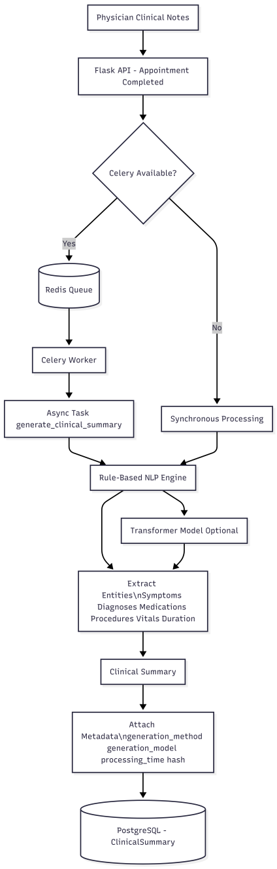
Figure 5.4: Clinical NLP Processing Pipeline

5.5 Demand Forecasting
The forecasting module, implemented in backend/forecaster.py, provides short-horizon projections of patient appointment volume and resource utilisation across four operational modes:
Mode | Algorithm | Use Case | Dependency
baseline | Statistical (moving avg + trend) | Always available; low data needs | None (built-in)
arima | AutoARIMA via pmdarima | 30+ days of history | pmdarima (optional)
lightgbm | Gradient boosted trees | 90+ days; rich features | lightgbm (optional)
auto | Selects best model by cross-val | Production adaptive selection | pmdarima + lightgbm
Table 5.3: Forecasting Model Comparison
Forecast outputs are cached in Redis to avoid redundant computation and are also persisted in ForecastHistory with model metadata and confidence intervals.

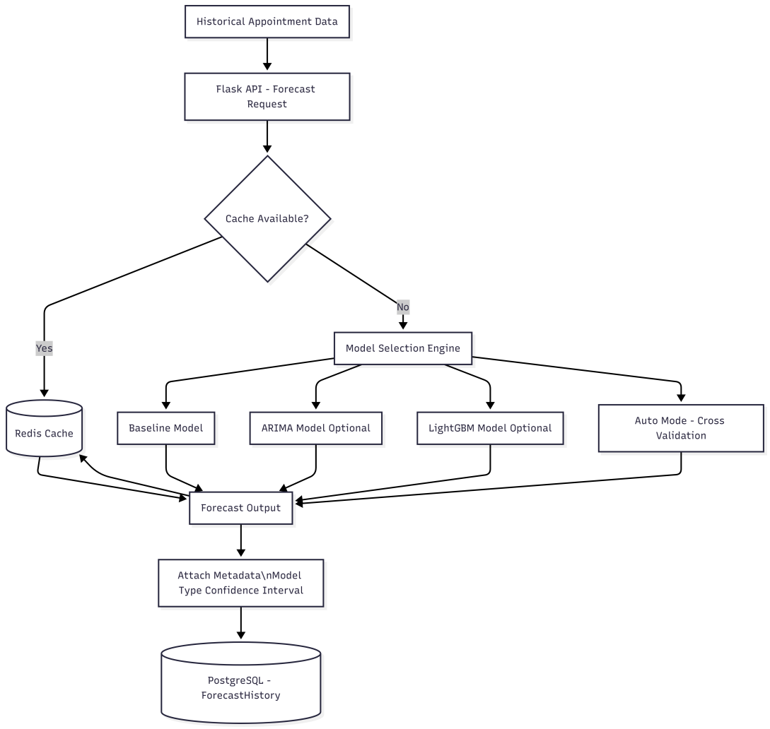
Figure 5.5: Forecasting Module Architecture

5.6 Monitoring and Alerting
Operational observability is provided by a Prometheus + Grafana stack fully wired into the Docker Compose configuration. Prometheus scrapes /metrics at regular intervals and stores time-series data. Grafana reads from the Prometheus data source and renders a pre-provisioned operational dashboard covering API request rates, error rates, Celery task throughputs, workload scores, and database connection pool utilisation.
Alert rules defined in monitoring/prometheus/alerts.yml cover four critical events: (1) Database connectivity down — triggers if PostgreSQL is unreachable for more than 60 seconds. (2) Redis connectivity down — triggers if Celery worker heartbeat goes stale. (3) Stale backup age — triggers if no successful backup has completed within the retention window. (4) Stale worker heartbeat — triggers if no Celery worker has checked in within the heartbeat timeout.

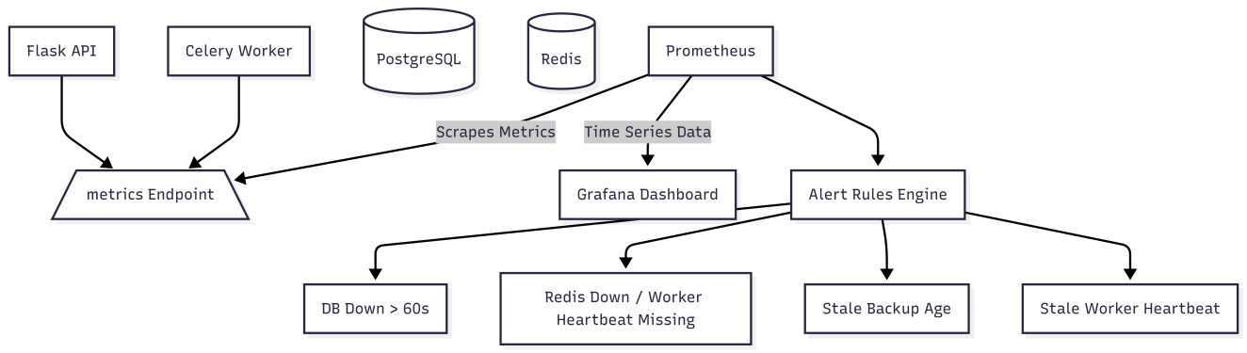
Figure 5.6: Prometheus and Grafana Monitoring Stack

CHAPTER 6: RESULTS AND SYSTEM DEMONSTRATION

6.1 End-to-End Demo Flow
The following step-by-step walkthrough traces a complete patient journey through the platform, demonstrating the interaction between all major modules.

Step 1 – User Registration and Login
A new patient registers via the Vue.js frontend by submitting their details to POST /api/auth/register. The API validates the password policy, hashes the password with bcrypt, creates the User and PatientProfileCompat records, and returns a 201 response. On login, the API issues a JWT access token (15-minute TTL) and a refresh token stored in AuthSession. The frontend stores the token in memory and injects it into subsequent request headers.

Step 2 – Appointment Booking
The patient navigates to the Appointment Booking page. The frontend calls GET /api/appointments/available-slots to retrieve slots. The scheduling engine evaluates workload scores for each physician in the requested specialty and returns only slots where the assigned doctor’s score is below 0.85. The patient selects a slot and submits via POST /api/appointments/book. The Appointment record is persisted and a Celery task is enqueued to generate the initial clinical summary.

Step 3 – Doctor Consultation and Clinical Note Entry
The assigned doctor logs in and views their appointment queue. After completing the consultation, the doctor submits free-text clinical notes via the Note Entry form. The notes are submitted to POST /api/summaries/generate, which enqueues the async NLP Celery task. The doctor receives a notification when the summary is ready.

Step 4 – NLP Clinical Summary Generation
The Celery worker processes the NLP task. The rule-based extraction engine identifies entities including symptoms (e.g., chest pain, dyspnea), diagnoses (e.g., stable angina), medications (e.g., aspirin 81 mg), vitals (e.g., BP 130/85 mmHg), and duration expressions (e.g., 3 days). The structured summary is persisted as a ClinicalSummary record with content hash, generation method, and processing time metadata. The doctor can review, edit, and version the summary through the revision interface.

Step 5 – Admin Dashboard and Workload Monitoring
The hospital administrator views the Admin Dashboard by calling GET /api/dashboard/metrics, which returns real-time workload scores, appointment counts by department, task queue depths, and system health indicators. The Celery beat scheduler has been continuously updating WorkloadMetric records every 30 seconds.

Step 6 – Clinical Summary Review
The administrator reviews NLP-generated summaries in the Clinical Summaries section. Each summary displays extracted entities in structured format, generation method, processing time, and full revision history.

Step 7 – Monitoring and Alerting
The administrator opens Grafana at localhost:3000 and reviews the operational dashboard. Request throughput, error rates, Celery task success rates, and database pool utilisation are visible in real time. All alert rules display green status.

Step 8 – Automated Cloud Backup
Every 15 minutes, the Celery beat scheduler triggers run_backup. The task invokes pg_dump to create a .sql archive in /data/backups, computes SHA-256, and uploads the archive to s3://hospital-ops-backups/backups/ using the EC2 IAM role. The upload result including S3 key, ETag, and timestamp is returned in the task response and logged as an AsyncTaskEvent.

6.2 Summary of Demonstrated Results
The end-to-end demonstration validates the following system capabilities:
- Workload-balanced appointment scheduling operating in real time with deterministic overload detection and reassignment.
- Asynchronous NLP clinical summary generation with entity extraction completing within 1–3 seconds on typical note lengths.
- Periodic demand forecasting updating every 60 seconds with Redis-cached results.
- Fully automated S3 cloud backups every 15 minutes with checksum verification and retry logic.
- Real-time operational monitoring with Prometheus scraping and Grafana dashboard rendering.
- Secure, role-isolated multi-user access with JWT session management, RBAC, and append-only audit logging.

CHAPTER 7: DEPLOYMENT AND AWS INTEGRATION

7.1 Docker Compose Deployment
The complete platform is defined in a single docker-compose.yml file at the repository root. Deployment to any Linux host requires only Docker Engine, Docker Compose, and the provisioning of appropriate environment variables and TLS certificates. The deployment procedure is:
- Provision an AWS EC2 instance (t3.medium or larger) with the hospital-ec2-role IAM instance role attached.
- Clone the repository and populate the .env.production file with secrets (JWT_SECRET_KEY, POSTGRES_PASSWORD, etc.).
- Place TLS certificate and key files in the paths referenced by the Nginx configuration.
- Run docker compose up -d to start all nine services. The API container automatically executes alembic upgrade head on startup.
- Verify deployment using scripts/check_stack.py, which probes the health, deep-health, dashboard, and metrics endpoints.
Public-facing ports 8080 and 8443 are bound to all interfaces (0.0.0.0). Prometheus (9090) and Grafana (3000) are localhost-bound and accessible only via SSH tunnelling.

7.2 AWS S3 Backup Integration
The backup pipeline uploads generated archives to Amazon S3 while preserving local backup behaviour. The complete flow is:
- The local backup file is created first — a .sql archive via pg_dump for PostgreSQL, or a .db copy for SQLite.
- After successful local creation, an S3 upload is attempted using a boto3 S3 client instantiated with the default credential chain (resolving to the EC2 instance metadata service).
- Upload success or failure is logged and returned in the task output as an s3_upload object.
- Retry with exponential backoff handles transient S3 failures up to S3_UPLOAD_MAX_ATTEMPTS.
- No static AWS access keys are embedded anywhere in source code or Compose configuration.
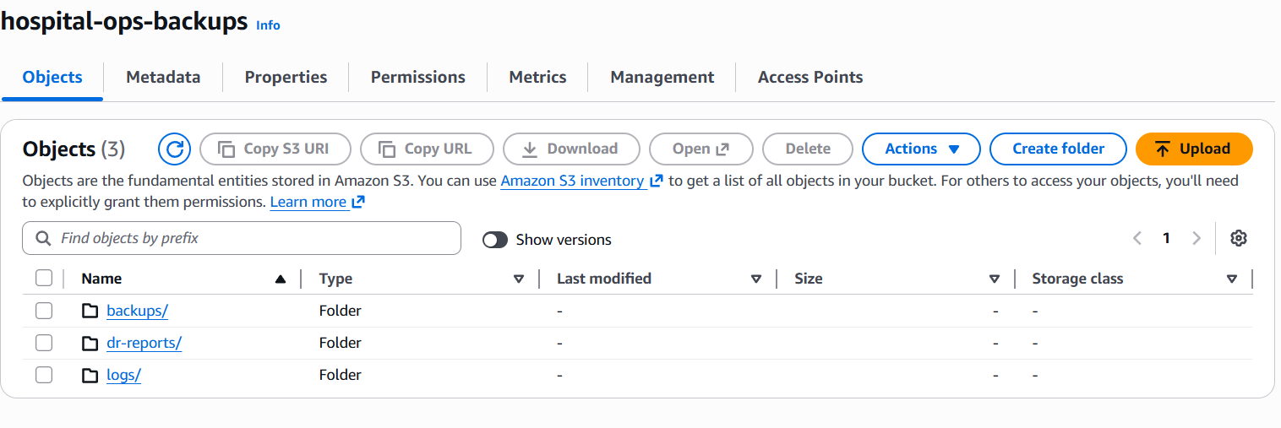]
Figure 7.1: AWS S3 Backup Integration Architecture
Variable | Demo Value | Purpose
AWS_DEFAULT_REGION | eu-north-1 | Target AWS region for S3 operations
S3_BACKUP_BUCKET | hospital-ops-backups | S3 bucket name for backup uploads
S3_BACKUP_PREFIX | backups | Key prefix for backup objects
S3_BACKUP_UPLOAD_ENABLED | True | Enables/disables S3 upload in backup task
S3_UPLOAD_MAX_ATTEMPTS | 3 | Maximum retry attempts for transient failures
SSE_MODE | AES256 | Server-side encryption mode for uploaded objects
KMS_KEY_ARN | (empty) | Optional KMS key ARN for SSE-KMS encryption
Table 7.1: AWS Environment Variables

7.3 IAM Role and Credential Model
The execution identity for all AWS operations is the EC2 instance role hospital-ec2-role. Boto3 resolves credentials through the default credential chain, fetching temporary security credentials from the EC2 Instance Metadata Service (IMDS) without requiring static access keys. This follows the AWS principle of least privilege and eliminates the risk of key exposure through configuration files or environment variables.
Minimum IAM permissions required:
- s3:PutObject on arn:aws:s3:::hospital-ops-backups/backups/*
- s3:ListBucket on arn:aws:s3:::hospital-ops-backups (with backups/ prefix condition)
- s3:GetBucketLocation on arn:aws:s3:::hospital-ops-backups
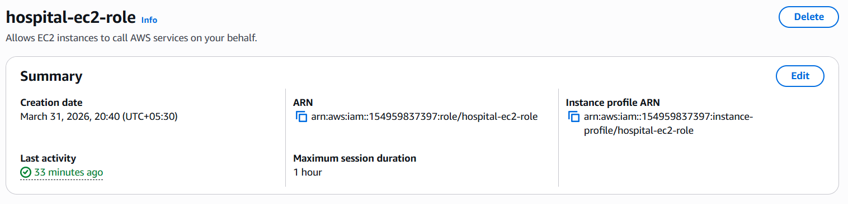
Figure 7.2: IAM Role Credential Chain
{
"Version": "2012-10-17",
"Statement": [
{
"Sid": "ListBucket",
"Effect": "Allow",
"Action": "s3:ListBucket",
"Resource": "arn:aws:s3:::hospital-ops-backups"
},
{
"Sid": "ObjectAccess",
"Effect": "Allow",
"Action": [
"s3:PutObject",
"s3:GetObject",
"s3:DeleteObject"
],
"Resource": "arn:aws:s3:::hospital-ops-backups/*"
}
]
}
Reference IAM Policy for Demo Deployment

7.4 S3 Bucket Prefix Structure
s3://hospital-ops-backups/
├── backups/ ← Automated Celery backup uploads (active)
├── dr-reports/ ← DR drill report uploads (reserved)
└── logs/ ← Operational log archival (reserved)
Figure 7.3: S3 Bucket Prefix Structure

7.5 Encryption and Reliability Settings
All backup objects are encrypted at rest using AES-256 server-side encryption (SSE-S3), configured via SSE_MODE=AES256. An SSE-KMS pathway is available by providing a KMS_KEY_ARN value for compliance-sensitive deployments. Retry logic uses exponential backoff with jitter. Local backup files are always created before upload is attempted, ensuring a failed upload does not result in data loss.

7.6 End-to-End Validation Procedure
The AWS integration was validated using:
# Trigger backup from worker container
docker compose exec celery_worker python -c \
"from tasks import run_backup; import json; print(json.dumps(run_backup.apply().result, indent=2))"

# Verify S3 upload
aws s3 ls s3://hospital-ops-backups/backups/ | tail -n 10

# Verify EC2 IAM identity
aws sts get-caller-identity

CHAPTER 8: TESTING AND VALIDATION

8.1 Test Suite Overview
Test Module | Coverage Area | Key Assertions
test_scheduling.py | Scheduling / availability | Overload threshold, conflict prevention, emergency override
test_app_flow.py | End-to-end API flow | Login, booking, summary retrieval, role isolation
test_forecasting.py | Forecasting / NLP behaviour | Baseline accuracy, entity extraction correctness
test_transformer.py | Transformer mode handling | Graceful fallback when optional deps absent
test_payment.py | Payment flow integration | Order creation, status transitions, webhook handling
test_backup_restore.py | Backup / restore scripts | Checksum verification, path validation, restore safety
test_ops_scripts.py | Ops script URL/path parsing | API_BASE override, safe path construction
test_dr_drill.py | DR drill execution | Report JSON schema, exit status, duration calc
test_tls.py | TLS and production config | Cert/key presence, HTTPS redirect, production flag
test_postgres.py | PostgreSQL config | DSN parsing, migration application, query safety
Table 8.1: Test Suite Coverage Summary
Tests are executed using pytest. Key testing strategies:
- Mock injection for external dependencies (boto3, Celery broker) ensures tests are reproducible without live AWS or Redis connectivity.
- SQLite in-memory databases are used for unit-level database tests, avoiding the need for a running PostgreSQL instance during CI.
- Integration tests use the Flask test client with a test-mode SQLite database configured by TEST_DATABASE_URL.
- Ops script tests validate URL construction and path parsing with boundary conditions including empty strings, relative paths, and environment variable overrides.

8.2 Disaster Recovery Drill
The disaster recovery drill tooling (scripts/run_dr_drill.py) provides automated end-to-end validation of the backup and restore pipeline. The drill programmatically executes the following steps:
- Trigger a backup task and wait for completion.
- Locate the most recent local backup file.
- Invoke scripts/restore_backup.py with checksum verification enabled.
- Record the outcome (exit status, stdout/stderr tails, duration) in a machine-readable JSON report.
The report JSON includes timestamps, duration in seconds, exit code, and parsed DR_REPORT block, enabling automated drill scheduling and audit-trail generation. The restore script implements strict safety checks including filesystem-only path validation (no :memory: SQLite targets), checksum verification against the stored SHA-256 hash, and a dry-run mode for non-destructive validation.

CHAPTER 9: CHALLENGES AND LIMITATIONS

9.1 Technical Challenges

9.1.1 Workload Score Calibration
Determining appropriate weights for the four workload score components required iterative calibration. Initial equal weighting (0.25 each) produced unstable reassignment behaviour under simulated load. The final weights were derived through simulation with synthetic appointment data and validated against expected scheduling outcomes.

9.1.2 Celery Task Reliability
Early testing revealed that Celery workers could silently drop tasks under Redis memory pressure. This was mitigated by configuring Redis with an allkeys-lru eviction policy and implementing AsyncTaskEvent logging to detect dropped tasks.

9.1.3 NLP Rule Coverage
Rule-based NLP extraction exhibits lower recall for non-standard medical abbreviations and informal documentation styles. Expanding entity dictionaries required significant domain knowledge and manual validation. The optional transformer pathway addresses this limitation at the cost of additional compute requirements.

9.1.4 Alembic Migration Ordering
Introducing the second Alembic migration required careful dependency declaration to ensure correct upgrade ordering in CI and production environments. A missing downgrade path in the initial revision was identified and corrected during testing.

9.1.5 React Auth Assets Integration
A parallel React/Vite authentication workspace (frontend-react-auth) was developed but could not be fully integrated into the active Nginx configuration before the submission deadline.

9.2 Current Limitations
- Production readiness depends on correct secret, certificate, and environment management at deployment time.
- PostgreSQL backup/restore relies on the availability of pg_dump and psql binaries and appropriate network/credential configuration.
- Advanced forecasting (ARIMA, LightGBM) and NLP transformer paths require optional Python packages not installed by default.
- S3 backup integration is configured for a single AWS region. Cross-region replication for disaster recovery is not yet configured.
- The platform has not been load-tested beyond synthetic benchmarks; real-world throughput limits require further profiling.

CHAPTER 10: FUTURE ENHANCEMENTS

10.1 Kubernetes Deployment and Auto-Scaling
Migrating to Kubernetes (Amazon EKS) would enable horizontal pod auto-scaling for the Flask API and Celery worker tiers based on the Prometheus custom metrics already exposed by the platform.

10.2 Full React Frontend Integration
The React/Vite authentication workspace should be fully integrated into the Nginx configuration with dedicated routes for /login and /register, enabling a more modern authentication user experience.

10.3 Fine-Tuned Clinical NLP Model
Replacing the generic Hugging Face model with a clinical NLP model fine-tuned on MIMIC-III or i2b2 datasets would significantly improve entity extraction recall. Model serving via AWS SageMaker Inference Endpoints would provide scalable, managed inference.

10.4 Cross-Region S3 Replication
Enabling S3 Cross-Region Replication (CRR) for the hospital-ops-backups bucket would provide geographic redundancy, ensuring recovery is possible even during an AWS regional outage.

10.5 HIPAA Compliance Hardening
For real-world deployment, the platform would require HIPAA compliance controls including VPC network isolation, CloudTrail audit logging, AWS Config rules, encrypted EBS volumes, and a Business Associate Agreement (BAA) with AWS.

10.6 Real-Time Notification with WebSocket / SSE
Replacing the polling-based notification model with WebSocket or Server-Sent Events (SSE) channels would enable real-time push notifications for appointment status changes, summary readiness, and alert firings.

10.7 Multi-Tenancy Support
Extending the data model with a tenant_id discriminator would enable the platform to serve multiple hospital organisations from a single deployment with strict data isolation, making it viable as a SaaS offering.

10.8 Payment Gateway Integration
Completing the payment integration (signalled by the existing PaymentOrderCompat entity and test_payment.py suite) with a production payment gateway such as Stripe or Razorpay would enable end-to-end billing for appointment consultations.

CHAPTER 11: CONCLUSION

This project demonstrates the successful design, implementation, and deployment of a Cloud-Native Intelligent Hospital Operations Platform that addresses six key operational deficiencies identified in contemporary hospital information systems.
The platform integrates a workload-aware intelligent scheduling engine, asynchronous NLP-driven clinical summary generation, short-horizon demand forecasting, a comprehensive observability stack, and a secure cloud backup pipeline backed by AWS S3 — all within a containerised, reproducible, and production-aligned architecture. The workload scoring algorithm provides a deterministic, quantitative basis for appointment assignment and reassignment. The NLP pipeline transforms unstructured clinical notes into structured, reviewable summaries, reducing physician documentation overhead.
The AWS S3 backup integration exemplifies cloud computing principles in practice: managed object storage accessed via IAM role-based credentials (eliminating static key risks), retry-resilient upload logic, AES-256 server-side encryption, and a structured prefix model for future expansion. The Prometheus + Grafana observability stack and automated disaster recovery drill tooling bring the platform to a standard of operational maturity rarely seen in academic prototypes.
Security is treated as a first-class concern throughout the architecture — from bcrypt password hashing and JWT refresh session management to append-only audit logging, login lockout, and rate limiting. The Alembic migration framework ensures that schema evolution is traceable, reversible, and repeatable across environments.
Overall, this project serves as a compelling demonstration of full-stack cloud-native software engineering, encompassing backend API design, database modelling, asynchronous task orchestration, machine learning integration, cloud service utilisation, DevOps tooling, and security engineering. The codebase is of sufficient depth and breadth to serve as a strong foundation for further research, commercial development, or technical interview discussion in the domain of cloud-native healthcare software.

REFERENCES

[1] Cayirli, T. and Veral, E. (2003). Outpatient scheduling in health care: A review of literature. Production and Operations Management, 12(4), 519–549.
[2] Gupta, D. and Denton, B. (2008). Appointment scheduling in health care: Challenges and opportunities. IIE Transactions, 40(9), 800–819.
[3] Aronson, A. R. (2001). Effective mapping of biomedical text to the UMLS Metathesaurus. AMIA Annual Symposium Proceedings, 17–21.
[4] Savova, G. K. et al. (2010). Mayo clinical Text Analysis and Knowledge Extraction System (cTAKES). JAMIA, 17(5), 507–513.
[5] Lee, J. et al. (2019). BioBERT: A pre-trained biomedical language representation model. Bioinformatics, 36(4), 1234–1240.
[6] Alsentzer, E. et al. (2019). Publicly Available Clinical BERT Embeddings. NAACL Workshop on Biomedical NLP, 72–78.
[7] Marcilio, I. et al. (2013). Application of autoregressive integrated moving average models for forecasting emergency department visits. Academic Emergency Medicine, 20(5), 483–490.
[8] Ke, G. et al. (2017). LightGBM: A highly efficient gradient boosting decision tree. NeurIPS, 30, 3146–3154.
[9] Menachemi, N. and Collum, T. H. (2011). Benefits and drawbacks of electronic health record systems. Risk Management and Healthcare Policy, 4, 47–55.
[10] Poniszewska-Maranda, A. et al. (2021). A practical approach to microservices architecture for cloud-native applications. Journal of Ambient Intelligence and Humanized Computing, 12, 4041–4057.
[11] Amazon Web Services (2024). Amazon S3 Developer Guide. https://docs.aws.amazon.com/s3/
[12] Amazon Web Services (2024). IAM Roles for Amazon EC2. https://docs.aws.amazon.com/IAM/
[13] Pallets Projects (2024). Flask Documentation (3.x). https://flask.palletsprojects.com/
[14] PostgreSQL Global Development Group (2024). PostgreSQL 16 Documentation. https://www.postgresql.org/docs/16/
[15] Prometheus Authors (2024). Prometheus Documentation. https://prometheus.io/docs/
[16] Grafana Labs (2024). Grafana Documentation. https://grafana.com/docs/
[17] Celery Project (2024). Celery: Distributed Task Queue. https://docs.celeryq.dev/
[18] Alembic Authors (2024). Alembic Documentation. https://alembic.sqlalchemy.org/

